LAB 8

Name: Disha Agarwal Registration number: 210905412 Branch: CSE A

Design 1

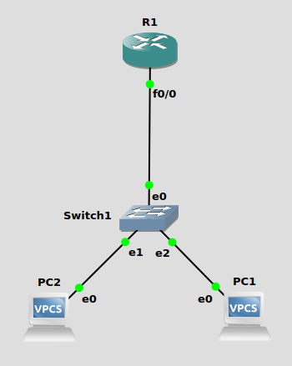
R1
conf t
IP dhcp pool NAME
Network 192.168.3.0 255.255.255.0
Default-router 192.168.3.1
int f0/0
no shut
ip address 192.168.3.1 255.255.255.0

PC1> dhcp
DDORA IP 192.168.3.2/24 GW 192.168.3.1

PC2> dhcp
DDORA IP 192.168.3.3/24 GW 192.168.3.1

Design 2

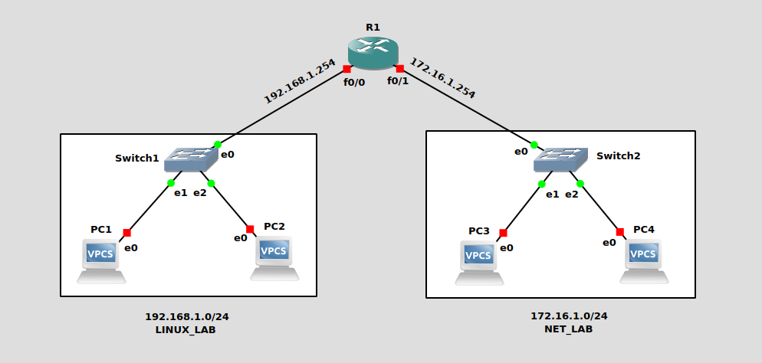

R1:
conf t

IP dhcp pool LINUX_LAB
Network 192.168.1.0 255.255.255.0
Default-router 192.168.1.254

int f0/0
no shut
ip address 192.168.1.254 255.255.255.0

IP dhcp pool NET_LAB
Network 172.16.1.0 255.255.255.0
Default-router 172.16.1.254

int f0/1
no shut
ip address 172.16.1.254 255.255.255.0

do wr
exit

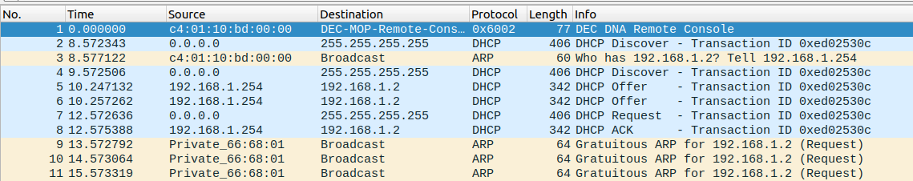

PC2> dhcp
DDORA IP 192.168.1.2/24 GW 192.168.1.254

Design 3

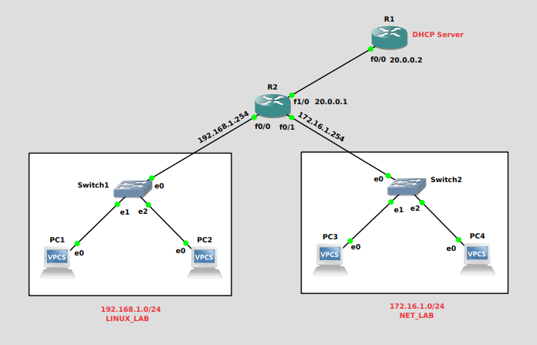

R1:
conf t
int f0/0
no shut
ip address 20.0.0.2 255.255.255.0
exit
IP dhcp pool LINUX_LAB
Network 192.168.1.0 255.255.255.0
Default-router 192.168.1.254
IP dhcp pool NET_LAB
Network 172.16.1.0 255.255.255.0
Default-router 172.16.1.254
exit
ip route 172.16.1.0 255.255.255.0 20.0.0.1
ip route 192.168.1.0 255.255.255.0 20.0.0.1
do wr
exit

R2:
conf t

int f0/0
no shut
ip address 192.168.1.254 255.255.255.0
ip helper-address 20.0.0.2
exit

int f0/1
no shut
ip address 172.16.1.254 255.255.255.0
ip helper-address 20.0.0.2
exit

int f1/0
no shut
ip address 20.0.0.1 255.255.255.0
exit

do wr
exit

PC1> dhcp
DDORA IP 192.168.1.1/24 GW 192.168.1.254

